Test Case: tc001_SPX_Dev5_Crear_Solicitud_Articulo_Almacen
Step 1 - Enter username and password and click to button Enter : Credentials Entered
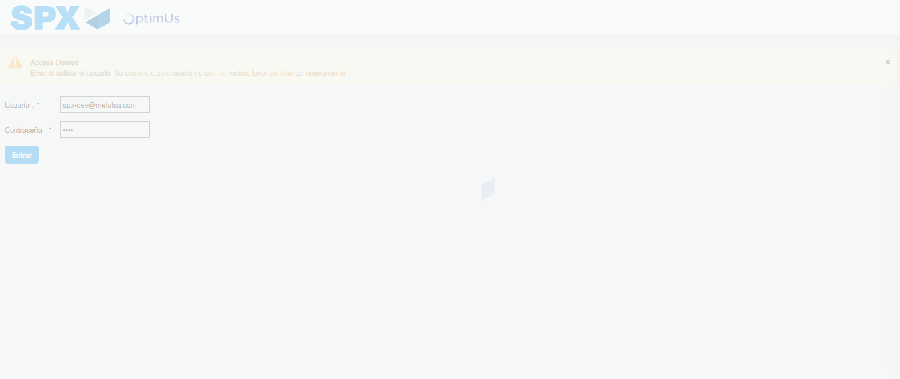Image file-name: QC_Testing-tc001_SPX_Dev5_Crear_Solicitud_Articulo_Almacen-1787933212711

Step 2 - Select to UEN and Access to Request for a New Inventory Item : UEN Correctly selected and Correct access
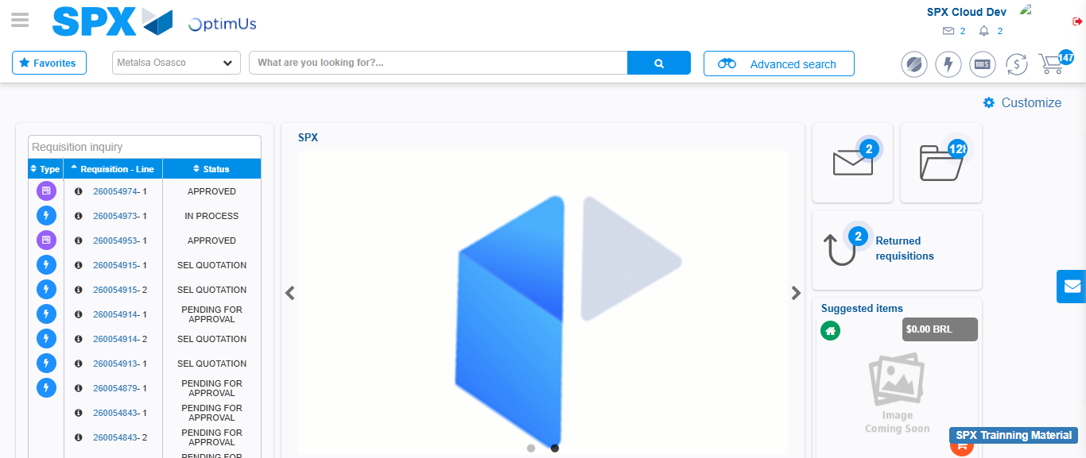Image file-name: QC_Testing-tc001_SPX_Dev5_Crear_Solicitud_Articulo_Almacen-1787933282177

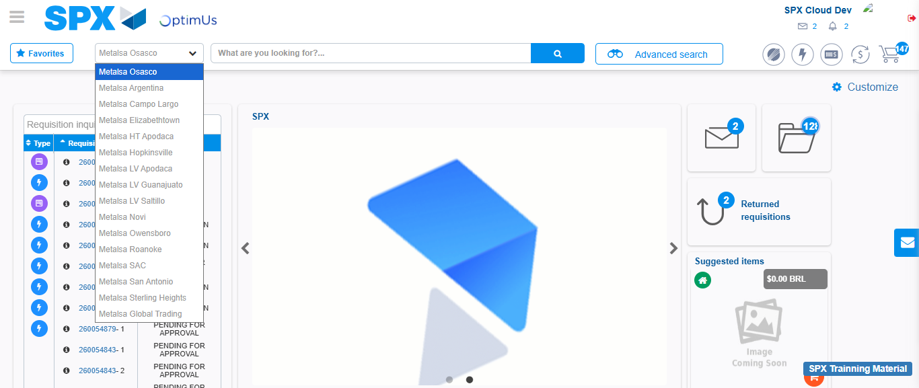Image file-name: QC_Testing-tc001_SPX_Dev5_Crear_Solicitud_Articulo_Almacen-1787933282873

Image file-name: QC_Testing-tc001_SPX_Dev5_Crear_Solicitud_Articulo_Almacen-1787933293886

Step 3 - Select options first section : Options seleted correctly
Image file-name: QC_Testing-tc001_SPX_Dev5_Crear_Solicitud_Articulo_Almacen-1787933294210

Image file-name: QC_Testing-tc001_SPX_Dev5_Crear_Solicitud_Articulo_Almacen-1787933294415

Step 4 - Select options at Screen: Options seleted correctly
Image file-name: QC_Testing-tc001_SPX_Dev5_Crear_Solicitud_Articulo_Almacen-1787933294210

Image file-name: QC_Testing-tc001_SPX_Dev5_Crear_Solicitud_Articulo_Almacen-1787933294415

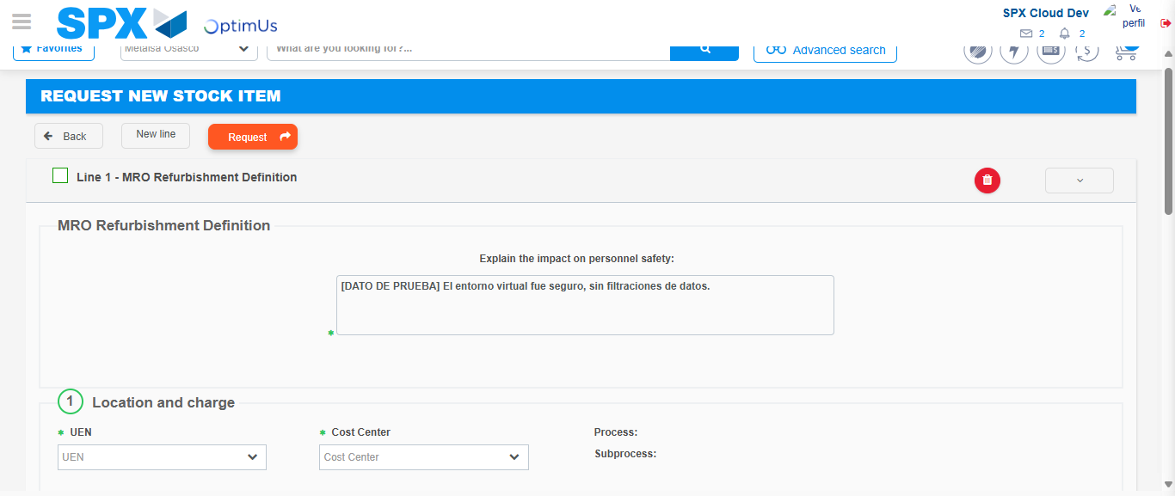Image file-name: QC_Testing-tc001_SPX_Dev5_Crear_Solicitud_Articulo_Almacen-1787933300721

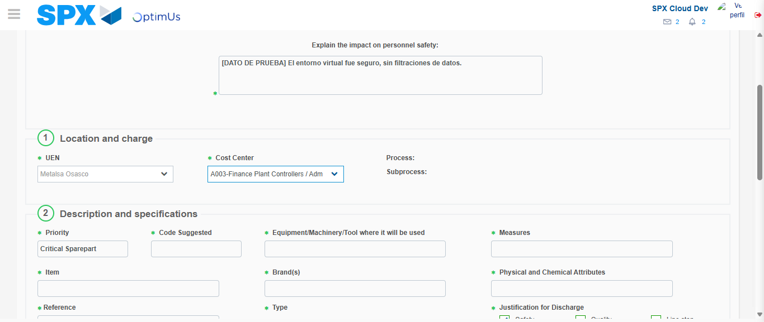Image file-name: QC_Testing-tc001_SPX_Dev5_Crear_Solicitud_Articulo_Almacen-1787933303454

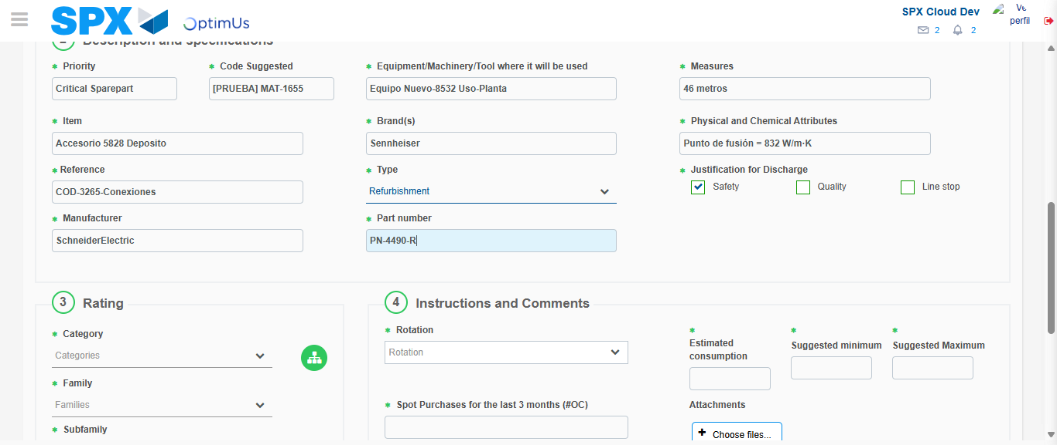Image file-name: QC_Testing-tc001_SPX_Dev5_Crear_Solicitud_Articulo_Almacen-1787933305397

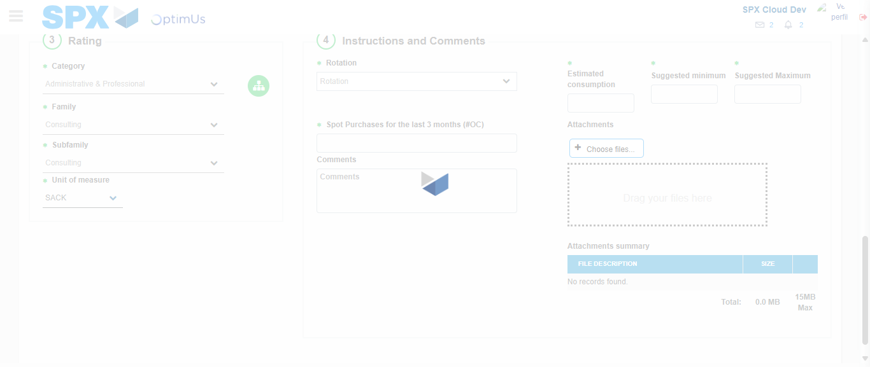Image file-name: QC_Testing-tc001_SPX_Dev5_Crear_Solicitud_Articulo_Almacen-1787933311280

Step 5 - Request New Item : Request Accepted
Image file-name: QC_Testing-tc001_SPX_Dev5_Crear_Solicitud_Articulo_Almacen-1787933282177

Image file-name: QC_Testing-tc001_SPX_Dev5_Crear_Solicitud_Articulo_Almacen-1787933282873

Image file-name: QC_Testing-tc001_SPX_Dev5_Crear_Solicitud_Articulo_Almacen-1787933293886

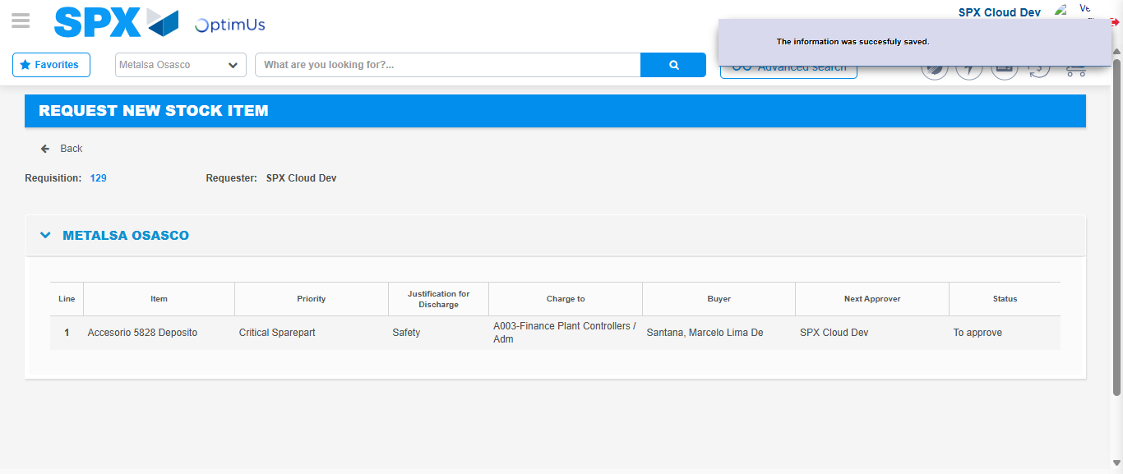Image file-name: QC_Testing-tc001_SPX_Dev5_Crear_Solicitud_Articulo_Almacen-1787933319163

Image file-name: QC_Testing-tc001_SPX_Dev5_Crear_Solicitud_Articulo_Almacen-1787933319368

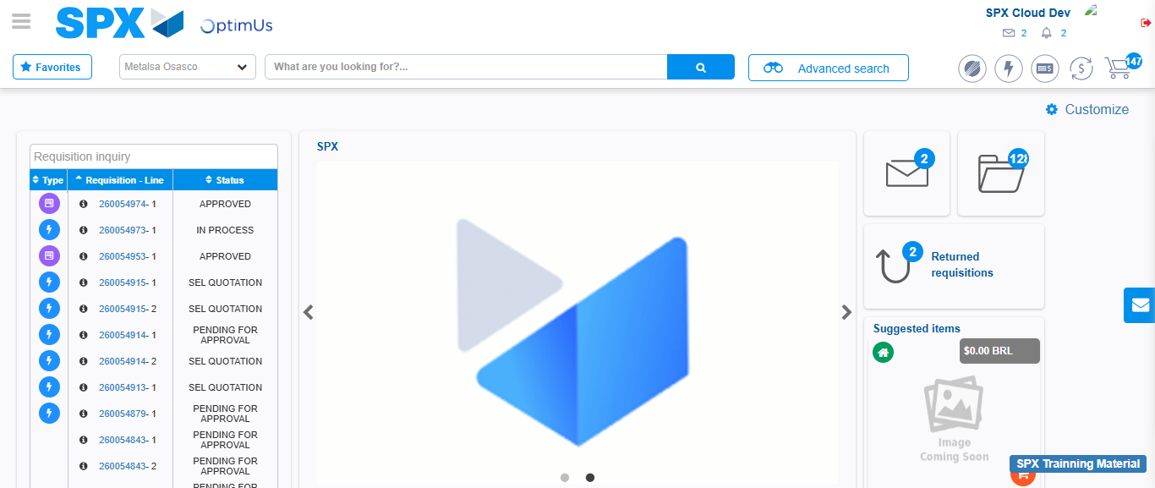Image file-name: QC_Testing-tc001_SPX_Dev5_Crear_Solicitud_Articulo_Almacen-1787933340966

Step 7 - Return to Main Page SPX : Return to Main Page SPX
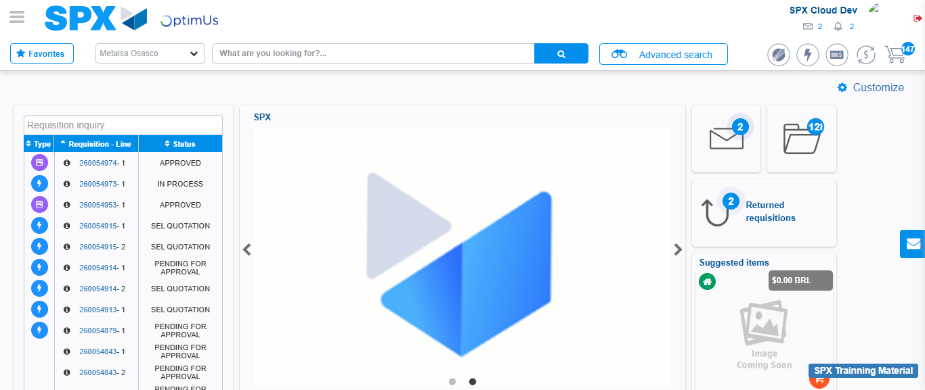Image file-name: QC_Testing-tc001_SPX_Dev5_Crear_Solicitud_Articulo_Almacen-1787933341423

